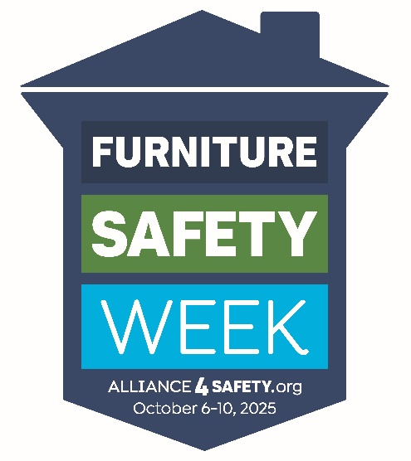

FOR IMMEDIATE RELEASE
October 3, 2025

OCTOBER 6-10 IS FURNITURE SAFETY WEEK!

[YOUR COMPANY’S CITY, STATE] – [Insert your Company Name] will join with the Alliance4Safety October 6-10 to help raise awareness of furniture-related hazards in the home as part of the second annual Furniture Safety Week.

From 2013 to 2023, 58 children died when a piece of furniture tipped over on them, according to the U.S. Consumer Product Safety Commission. Another 50 died during the same time period when a TV plus the furniture it was sitting on tipped over. Together these two types of accidents result in the death of one child every month.

Bunk beds, reclining furniture and glass tabletops also contribute to serious childhood injuries, but safety advocates often label these “hidden hazards.” The purpose of Furniture Safety Week is to shine the spotlight on accidents involving furniture so parents and caregivers can take steps to prevent them.

The weeklong initiative involves manufacturers, retail stores, online stores, interior designers, parents, child safety advocates and others.

“At [insert Company Name], child safety is a priority. By participating in Furniture Safety Week, we can amplify our voice and help bring ‘hidden’ hazards out to the open,” said [company spokesperson].

[Company Name] recommends that [name of city or state] residents take these 5 simple steps to help keep everyone, especially children, safe at home:

- Close the drawer on tip-overs. Even lighter weight and shorter furniture can tip, so anchor anything with drawers or shelves toddlers might be tempted to climb. Store heavier items in bottom drawers and keep remote controls, toys and other tempting items off the tops of TVs and furniture where children can see but not reach them. Complete anchoring instructions can be found at https://anchorit.gov.

- Stay on top of bunk bed safety. Bunk beds are a blast for kids and a great space-saver for small bedrooms (and big families!) But the U.S. Consumer Product Safety Commission says children under age 6 should never use the top bunk, and for good reason. More than half of all bunk bed-related injuries involve kids under 6. Current standards call for precise measurements for the top railings, NO finials or post extensions on the top bunk, and a detailed warning label that includes the exact-size mattress recommended for both the top and bottom bunk.

- Relax safely. Reclining furniture is fascinating to small children, especially if it has power features. But fingers and limbs can be pinched by a folding footrest, so it’s best to keep kids (and pets) in view when closing your recliner or lift chair.

- Keep safety in clear view. An estimated 2.5 million people – mostly children under 7 and adults in their early 20s – injure themselves on broken glass tabletops each year. Make sure glass tabletops, whether inside or outside, are made of tempered glass, which is stronger and breaks into small pieces rather than jagged shards. (To determine if glass is tempered, grab a pair of polarized sunglasses. Tempered glass will have a distinctive grid pattern when viewed through polarized lenses.)

- Stay tuned to TV safety. If possible, wall-mount all TVs in your home. Place any units that cannot be wall-mounted on a low, sturdy cabinet, and secure the TV to the wall or to the furniture with a TV anchor. Never place a TV on furniture that was not built to hold electronics.

###

The Alliance4Safety was created in 2020 to convey health and safety information related to the COVID-19 pandemic to furniture companies and their customers. Its focus was expanded in 2023 to communicate a broader range of home health and safety messages to consumers.

